Module 1 – SE - Overview of IT Industry
- What is a Program? Explain in your own words what a program is and how it functions.

- A program is a set of instructions written in a programming language that tells a computer what to do and how to do it.

In simple words:
A program is like a recipe for a computer.
Just like a recipe tells a cook the steps to make a dish, a program tells the computer the steps to perform a task.

How it works:
- You write instructions (in languages like Python, C, Java, etc.).
- The computer reads these instructions, one by one.
- It executes them in order — doing calculations, storing data, showing output, etc.
- The result is the task you want the computer to perform (e.g., playing a song, logging in to a website, calculating numbers).

Example:
If you write a program to add two numbers:
- The instructions tell the computer to take two numbers → add them → show the result.

In short:
A program is a set of commands that controls the behavior of a computer and allows it to perform specific tasks.

- What is Programming?What are the key steps involved in the programming process?

- Programming is the process of creating instructions (programs) that a computer can understand and execute.
It involves planning, writing, testing, and improving code to solve a problem or perform a specific task.

Key Steps in the Programming Process

1. Problem Definition
Understand what you want to achieve.
Example: “Create a program to calculate the area of a circle.”

2. Planning & Algorithm Design
Think through the steps needed to solve the problem.
This includes:
- Writing an algorithm (step-by-step procedure)
- Drawing a flowchart (optional but helpful)

3. Writing the Code (Coding)
Translate the algorithm into a programming language
(e.g., Python, C, Java, JavaScript).

4. Compilation/Interpretation
Convert the written code into a form the computer understands:
- Compiler converts whole code at once (e.g., C, C++)
- Interpreter executes code line by line (e.g., Python)

5. Testing & Debugging
Run the program to check if it works correctly.
Fix errors (bugs) if the program does not behave as expected.

6. Execution
Once error-free, the program is executed to perform the desired task.

7. Documentation
Write comments or documents explaining:
- how the program works,
- how to use it.

8. Maintenance
Update and improve the program as needed—add features, fix new bugs, or adapt to new requirements.

Short Answer Summary
Programming is the process of designing, writing, testing, and maintaining instructions for a computer.
The key steps include:
Problem definition → Planning → Coding → Compilation/Interpretation → Testing → Execution → Documentation → Maintenance.

- Types of Programming Languages. What are the main differences between high-level and low-level programming languages?

- Programming languages are commonly divided into two major types:

1. High-Level Programming Languages
Examples: Python, Java, C#, JavaScript, PHP, Ruby
These languages are closer to human language and easier to read, write, and understand.

2. Low-Level Programming Languages
Examples: Assembly language, Machine language
These languages are closer to the computer’s hardware and are more difficult for humans to understand.

Differences Between High-Level and Low-Level Languages
Feature | High-Level Languages | Low-Level Languages
Closeness to hardware | Far from hardware (human-friendly) | Very close to hardware (machine-friendly)
Ease of coding | Easy to write, read & maintain | Harder to write, requires technical knowledge
Execution speed | Slower because translation is needed | Faster because it interacts directly with hardware
Portability | Highly portable (run on many systems) | Less portable (hardware-specific)
Examples | Python, Java, C++, JavaScript | Assembly, Machine Code
Translation | Uses compilers/interpreters | Uses assemblers

Simple Explanation

High-Level Languages
- Look like English.
- Great for beginners.
- You focus on what to do, not how the computer does it.
- Need to be translated into machine code.
Example:
print("Hello World")

Low-Level Languages
- Look like numeric or symbolic codes.
- Hard for humans but easy for computers.
- Used in system programming like OS, drivers, firmware.
Example (Assembly):
MOV A, 05
ADD A, 03

In short:
- High-level = easy for humans, slower for computers
- Low-level = hard for humans, fast and hardware-specific
- World Wide Web & How Internet Works. Describe the roles of the client and server in web communication.

- When you use the internet (e.g., open a website), two main components interact:

1. Client
The client is the device or software that requests information.

Examples of clients:
- Your computer or mobile phone
- Web browsers (Chrome, Firefox, Edge)

Client’s role:
- Sends a request to a server (like asking for a webpage).
- Receives the response from the server (like the webpage data).
- Displays the content to the user.
Example:
You type www.google.com → the browser sends a request to Google’s server.

2. Server
A server is a powerful computer that stores websites, applications, and data and provides them upon request.

Server’s role:
- Receives the client’s request.
- Processes it (fetching data, running scripts, checking databases).
- Sends back the response (HTML, images, videos, etc.)
Example:
Google’s server sends back the Google homepage to your browser.

How Client–Server Communication Works (Simple Steps)
- Client sends request
Example: Your browser asks for a webpage.
- Request travels through the internet
Using protocols like HTTP or HTTPS.
- Server receives and processes the request
It finds the correct files or runs backend code.
- Server sends response back to the client
This contains the webpage data.
- Client displays the result
Your browser shows the webpage to you.

Short Summary
- Client = asks for data (browser, phone, laptop).
- Server = provides data (website host, database server).
- They communicate using the client–server model, where the client requests and the server responds.
LAB EXERCISE: Research and create a diagram of how data is transmitted from a client to a server over the internet.
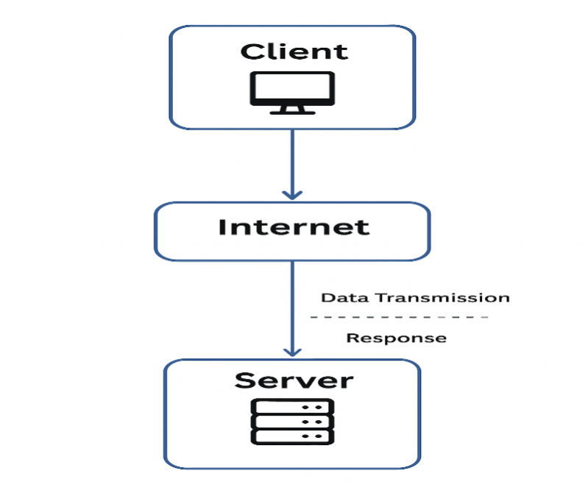
- Network Layers on Client and Server.Explain the function of the TCP/IP model and its layers.

Network Layers on Client and Server
When a client and server communicate over the internet, they both use a set of network layers to send and receive data.
These layers organize how data moves from one device to another.
Both Client and Server follow the TCP/IP Model, which contains 4 layers.
Each layer performs a specific function and passes data to the next layer.

🧩TCP/IP Model: Function and Layers
The TCP/IP Model is a set of networking rules (protocols) that allow devices to communicate over the internet.
It breaks communication into four layers, each responsible for a different part of data transmission.

🔹1. Application Layer
Purpose: Provides services directly to the user or application.

Functions:
- Enables software like browsers, email apps, and file transfer tools
- Handles high-level protocols:
  - HTTP (web pages)
  - HTTPS (secure web pages)
  - FTP (file transfer)
  - SMTP (email)
  - DNS (domain lookup)

Example:
A client’s browser sends an HTTP request → Server’s application layer receives it.

🔹2. Transport Layer
Purpose: Ensures reliable communication between client and server.

Protocols:
- TCP (Transmission Control Protocol)
✔ Reliable
✔ Connection-oriented
✔ Ensures packets arrive in order
- UDP (User Datagram Protocol)
✔ Fast
✔ No assurance of delivery

Functions:
- Breaks data into smaller segments
- Error checking
- Flow control
- Ensures complete data delivery

Example:
Client uses TCP to reliably send a web request to the server.

🔹3. Internet Layer
Purpose: Handles addressing and routing of data across networks.

Main Protocol:
- IP (Internet Protocol) — assigns addresses (IPv4/IPv6)

Functions:
- Determines the best route for the data
- Identifies source and destination by IP addresses
- Breaks data into packets

Example:
Client’s IP packet travels across routers until it reaches the server.

🔹4. Network Access Layer (Link Layer)
Purpose: Manages physical transmission of data over a network.

Functions:
- Converts IP packets into physical signals
- Uses MAC addresses for local delivery
- Works with hardware:
  - Ethernet
  - WiFi
  - Switches
  - Network Interface Cards (NICs)

Example:
Data travels as electrical signals through cables or WiFi waves.

📌Summary Table
Layer | Purpose | Protocols | Example
Application | User services & apps | HTTP, DNS, FTP | Browser sending request
Transport | Reliable communication | TCP, UDP | Splitting data into segments
Internet | Routing & addressing | IP | Choosing route via routers
Network Access | Physical transmission | Ethernet, WiFi | Sending signals through NIC

🧠How It Works Between Client and Server (Simple)

Client Side
- Browser creates HTTP request → Application Layer
- Request sent using TCP → Transport Layer
- TCP segments put into IP packets → Internet Layer
- Packets converted into signals → Network Access Layer

Server Side
- Signals received → Network Access Layer
- IP packets assembled → Internet Layer
- TCP segments reassembled → Transport Layer
- HTTP request given to the server → Application Layer
Then the server sends back a response using the same layer order in reverse.
- Client and Servers. Explain Client Server Communication
- Client–server communication is a way for two devices to interact over a network.
One device (client) makes a request, and another device (server) provides the response.
Think of it like:
Client = asks
Server = answers

🧩 Who is the Client?
A client is any device or software that requests a service or information.
Examples:
- Web browser (Chrome, Firefox)
- Mobile app
- Laptop or phone accessing a website
Client's Job:
- Send a request to the server
- Wait for the server's response
- Display the result to the user

🧩 Who is the Server?
A server is a high-powered computer that stores websites, apps, data, and services.
Server's Job:
- Receive the request from client
- Process the request (read data, run code, query database)
- Send back a response

🔄 How Client–Server Communication Works (Step-by-Step)
1. Client Sends a Request
Example:
You type www.google.com → your browser sends a request to Google’s server.
2. Request Travels Through Internet
The request passes through:
- WiFi router
- ISP
- Many networks and routers
- Finally reaches the server
3. Server Processes the Request
The server:
- Reads the request
- Runs code
- Fetches needed data
- Prepares the output (HTML, images, etc.)
4. Server Sends Back a Response
The response returns through the internet back to the client.
5. Client Displays the Result
Your browser shows the webpage.

📌 Example (Simple)
Client: "Give me the video page."
Server: "Here it is!"
Client: "Now send the video file."
Server: "Sending…"
Client keeps requesting → server keeps responding.

🔐 Which Protocols Are Used?
Client–Server communication uses:
- HTTP/HTTPS — for web pages
- TCP — for reliable delivery
- IP — for addressing and routing
- DNS — to find server’s IP address

📘 Short Exam-Friendly Answer
Client–server communication is a model where a client device requests data or services and a server responds with the required information. The client sends a request through the internet using protocols like HTTP, TCP, and IP. The server processes the request and sends back a response, which the client displays to the user.

- Types of Internet Connections. How does broadband differ from fiber-optic internet?
✅ Types of Internet Connections
Broadband vs. Fiber-Optic Internet
Both broadband and fiber-optic are common types of internet connections, but they work very differently and offer different performance levels.

🔹 What is Broadband?
Broadband usually refers to high-speed internet delivered through:
- DSL (telephone lines)
- Cable (coaxial cables)
- Satellite
How it works:
Broadband sends data through electrical signals over copper wires.
Characteristics:
- Good speed
- Affordable
- Widely available
- Can slow down due to distance or network congestion

🔹 What is Fiber-Optic Internet?
Fiber-optic internet uses thin glass or plastic fibers to transmit data using light signals, not electricity.
How it works:
Data travels as light pulses, which move extremely fast and do not lose signal quality.
Characteristics:
- Very high speed (up to 1 Gbps or more)
- More reliable
- No signal loss over long distances
- Best for heavy use (gaming, streaming, businesses)

🔄 Difference Between Broadband and Fiber-Optic Internet
Feature | Broadband (DSL/Cable) | Fiber-Optic Internet
Medium | Copper wires / coaxial cable | Glass/plastic fiber cables
Signal Type | Electrical signals | Light signals
Speed | Medium | Very High (fastest)
Reliability | Affected by distance & weather | Very stable and reliable
Distance | Signal weakens over long distance | No significant signal loss
Use Case | Normal home use | Heavy streaming, gaming, office work
Cost | Cheaper | A bit more expensive

📘 Short Exam-Friendly Answer
Broadband uses copper wires to transmit data through electrical signals, offering moderate speed and reliability.
Fiber-optic internet uses glass fiber cables to transmit data using light, providing much faster, more reliable, and long-distance performance without signal loss.

- Protocols. What are the differences between HTTP and HTTPS protocols?
- HTTP vs HTTPS Protocols
Both HTTP and HTTPS are used for transferring data between a client (browser) and a server over the internet.
However, they differ mainly in security.

🔹 HTTP (HyperText Transfer Protocol)
What it is:
- A protocol used for communication between web browsers and servers.
- Transfers data in plain text.
Characteristics:
- Not secure
- Data can be intercepted by hackers
- Uses port 80
- URL format: http://
When used:
- Basic websites
- Sites without sensitive information

🔹 HTTPS (HyperText Transfer Protocol Secure)
What it is:
- A secure version of HTTP.
- Encrypts data using SSL/TLS.
Characteristics:
- Secure
- Protects data from hackers
- Uses port 443
- URL format: https://
When used:
- Banking websites
- Online shopping
- Login pages
- Any site with personal/secure data

🔄 Differences Between HTTP and HTTPS
Feature | HTTP | HTTPS
Security | Not secure | Secure & encrypted
Data format | Plain text | Encrypted with SSL/TLS
Port Number | 80 | 443
URL Prefix | http:// | https://
Certificate Required? | No | Yes (SSL certificate)
Use Case | Simple sites | Secure transactions

📘 Short Exam-Friendly Answer
HTTP transfers data in plain text and is not secure.
HTTPS adds encryption using SSL/TLS, making it safe for sensitive data and secure communication.

- Application Security.
LAB EXERCISE: Identify and explain three common application security vulnerabilities. Suggest possible solutions.
- ✅ 1. SQL Injection (SQLi)
What is it?
SQL Injection happens when an attacker inserts malicious SQL commands into an input field (like login forms or search bars).
The server executes these commands because the input is not properly validated.
Example:
User enters:
' OR 1=1 --
This can trick the database into granting unauthorized access.
Possible Impact:
- Data theft
- Data deletion
- Full control of the database
Solution:
- Use Prepared Statements (Parameterized Queries)
- Validate and sanitize user inputs
- Use ORM frameworks
- Disable detailed error messages

✅ 2. Cross-Site Scripting (XSS)
What is it?
XSS occurs when an attacker injects malicious JavaScript into a webpage.
The script runs in the victim’s browser and can steal cookies, session data, or redirect users to malicious sites.
Example:
User inputs:
<script>alert("Hacked!")</script>
Possible Impact:
- Stealing user cookies
- Redirecting users
- Running malicious scripts on websites
Solution:
- Escape/encode all user input before displaying it
- Use security headers:
  - Content-Security-Policy (CSP)
- Sanitize input on both client and server
- Disable inline JavaScript

✅ 3. Cross-Site Request Forgery (CSRF)
What is it?
CSRF tricks a logged-in user into performing actions unknowingly (such as transferring money or changing passwords).
The attack works by sending a forged request to a server using the user’s existing authentication session.
Example:
A hidden malicious link:
<img src="http://bank.com/transfer?amount=5000&to=attacker">
Possible Impact:
- Unauthorized money transfer
- Changing user account settings
- Unauthorized actions on behalf of a user
Solution:
- Use CSRF tokens in forms
- Require re-authentication for sensitive actions
- Implement same-site cookies (SameSite=Lax or Strict)
- Validate the origin and referer headers

📌 Short Summary Table
Vulnerability | Meaning | Impact | Solution
SQL Injection | Injecting SQL commands into input | Data theft, DB damage | Parameterized queries, input validation
XSS | Injecting JavaScript into websites | Steal cookies, hijack sessions | Sanitize input, CSP
CSRF | Forcing users to perform unwanted actions | Unauthorized transactions | CSRF tokens, same-site cookies

THEORY EXERCISE :What is the role of encryption in securing applications Software Applications and Its Types?
- Encryption is a method of converting readable data (plaintext) into an unreadable format (ciphertext) so that only authorized users can understand it.
It is one of the most important technologies for securing applications.

🔐 Role of Encryption in Application Security
1. Protects Sensitive Data
Encryption ensures that private information such as:
- passwords
- banking details
- personal data
- confidential files
cannot be read even if intercepted by hackers.
Only someone with the correct key can decrypt and read it.

2. Prevents Data Theft During Transmission
When data travels across the internet, it can be intercepted.
Encryption (like HTTPS / SSL / TLS) makes this stolen data useless because it is unreadable without the key.
Example:
Online banking uses HTTPS so your financial data is encrypted.

3. Secures Stored Data (Data at Rest)
Applications often store data in databases or local storage.
Encrypted storage protects data even if:
- databases are hacked
- devices are stolen
- servers are compromised
Only authorized software can decrypt it.

4. Maintains Privacy and Confidentiality
Encryption ensures that only intended users access the data.
This is important for:
- medical apps
- messaging apps
- corporate systems
Example:
WhatsApp uses end-to-end encryption so only sender and receiver can read messages.

5. Helps Meet Security Standards
Many laws require encryption to protect user data:
- GDPR
- HIPAA
- PCI-DSS
- IT Act (India)
Applications use encryption to comply with these legal standards.

🛡️ Why Encryption Is Important (Short Answer)
Encryption prevents unauthorized access, protects data privacy, secures data during transmission, and ensures that even if data is stolen, it cannot be read without the decryption key.

📘 Software Applications and Its Types (Short Notes)
Software applications are programs designed to perform specific tasks for users.
Types of Software Applications:
1. Web Applications
Run in a browser
Examples: Gmail, YouTube, Online Banking
2. Mobile Applications
Run on smartphones
Examples: WhatsApp, Instagram, Google Maps
3. Desktop Applications
Installed on PC or laptop
Examples: MS Word, Photoshop, VLC Player
4. System Applications
Support system-level operations
Examples: Antivirus, Drivers, OS utilities
5. Enterprise Applications
Used by organizations
Examples: ERP, CRM, HRMS systems

- LAB EXERCISE: Identify and classify 5 applications you use daily as either system software or application software.

1. Google Chrome / Any Web Browser
Type: Application Software
Reason: It helps users browse the internet and is not required for basic system operation.

2. WhatsApp (Mobile/Desktop)
Type: Application Software
Reason: Used for communication, messaging, and calls.

3. Windows Operating System (or Android/iOS)
Type: System Software
Reason: Controls hardware and provides the environment for running applications.

4. File Explorer / Finder
Type: System Software
Reason: It is part of the operating system and helps manage files.

5. MS Word / Notepad
Type: Application Software
Reason: Used for writing documents and editing text.

📌 Short Summary Table
Application | Type
Google Chrome | Application Software
WhatsApp | Application Software
Operating System (Windows/Android) | System Software
File Explorer | System Software
MS Word / Notepad | Application Software

THEORY EXERCISE: What is the difference between system software and application software?
- Difference Between System Software and Application Software
🔹 System Software
System software is the foundational software that controls the hardware of a computer and provides a platform for running application software.
Key Features:
- Manages hardware components
- Runs in the background
- Needed for the system to start and function
- Fast and efficient
Examples:
- Operating Systems (Windows, Linux, Android, iOS)
- Device Drivers
- Utility Programs (Antivirus, File Management Tools)

🔹 Application Software
Application software is designed to help users perform specific tasks or activities on a computer or mobile device.
Key Features:
- User-focused
- Used to perform tasks like browsing, editing, listening to music
- Installed manually by users
- Depends on system software to run
Examples:
- MS Word
- Google Chrome
- WhatsApp
- VLC Media Player
- Games

📌 Major Differences (Table Format)
Feature | System Software | Application Software
Purpose | Manages hardware & system operations | Helps users perform tasks
Runs | Background | As per user request
Dependency | Runs without application software | Needs system software to run
User Interaction | Low | High
Examples | OS, Drivers, Utilities | Browsers, Games, Editors

📝 Short Exam-Friendly Answer
System software controls and manages computer hardware and provides the platform for running applications.
Application software helps users perform specific tasks like writing, browsing, or gaming.

- Software Architecture
THEORY EXERCISE: What is the significance of modularity in software architecture?
✅ Significance of Modularity in Software Architecture
Modularity means dividing a software system into smaller, independent parts called modules.
Each module performs a specific function and can work independently.

🔹 1. Improves Maintainability
Because each module is separate, fixing bugs or updating features becomes easier.
Developers can work on one module without affecting the entire system.

🔹 2. Enhances Reusability
A well-designed module can be reused in:
- other parts of the same project
- future projects
This saves time and effort.

🔹 3. Enables Parallel Development
Different team members can work on different modules at the same time.
This reduces development time and increases productivity.

🔹 4. Increases Scalability
Modular systems are easier to expand.
New modules can be added without changing the whole architecture.
Example: Adding a new payment method to an e-commerce app.

🔹 5. Improves Testing
Each module can be tested individually (unit testing) before integrating.
This leads to fewer errors and better software quality.

🔹 6. Enhances Flexibility
Modules can be replaced or upgraded independently.
This allows the system to evolve over time without major redesign.

📘 Short Exam Answer
Modularity means breaking software into independent modules. It improves maintainability, reusability, scalability, testing, flexibility, and allows parallel development. It helps build cleaner, more reliable, and easy-to-update software systems.

- Layers in Software Architecture. Why are layers important in software architecture?
- Why Layers Are Important in Software Architecture
Layered architecture divides a software system into separate levels, where each level has a specific responsibility.
Examples of layers:
- Presentation Layer (UI)
- Business Logic Layer
- Data Layer
Layers bring many advantages:

🔹 1. Separation of Concerns
Each layer handles only one type of responsibility.
This makes the system easier to understand and reduces complexity.
Example:
UI handles display, business layer handles logic, data layer handles database.

🔹 2. Easier Maintenance
If a problem occurs in one layer, you can fix it without touching the whole system.
This reduces errors and saves development time.

🔹 3. Reusability
Layers such as the business logic or data access layer can be reused in other applications or modules.

🔹 4. Scalability
Layers allow systems to grow easily.
You can add new features to one layer without affecting others.

🔹 5. Improved Testing
Each layer can be tested independently (unit testing), making it easier to catch bugs early.

🔹 6. Flexibility and Replaceability
Because layers are independent, one layer can be replaced/upgraded without changing the rest of the system.
Example:
Switching from MySQL to MongoDB only affects the data layer.

🔹 7. Better Team Collaboration
Different developers or teams can work on different layers simultaneously, increasing productivity.

📘 Short Exam Answer
Layers are important because they separate responsibilities, improve maintainability, support scalability, increase flexibility, allow independent testing, and make the system easier to understand and modify.

- Software Environments. Explain the importance of a development environment in software production?
- Importance of a Development Environment in Software Production
A development environment is the workspace where software is built, tested, and improved.
It includes tools like:
- Code editors (VS Code, IntelliJ)
- Compilers/interpreters
- Testing tools
- Debuggers
- Local servers
- Version control (Git)
A well-designed development environment is essential for producing high-quality software.

🔹 1. Provides a Safe Space for Development
Developers can write, run, and test code without affecting the real system.
Mistakes can be made safely during development.

🔹 2. Improves Productivity
Tools like auto-completion, linters, and debuggers make coding faster and reduce errors.
This helps developers work efficiently.

🔹 3. Ensures Consistency Across Teams
A shared development environment makes sure everyone uses:
- the same libraries
- the same versions
- the same configurations
This avoids “it works on my machine” problems.

🔹 4. Helps in Testing and Debugging
Developers can run unit tests, debug errors, and simulate real-world behavior before deployment.
This reduces bugs in the final product.

🔹 5. Supports Collaboration
With tools like Git and project management systems, multiple developers can:
- work together
- merge changes
- track versions
This speeds up development and keeps the project organized.

🔹 6. Enables Faster Deployment
When the development environment matches the production environment, software can be deployed easily with fewer errors.

📘 Short Exam Answer
A development environment is important because it provides a safe space to build and test software, improves productivity, ensures consistency across developers, supports debugging and teamwork, and helps deliver high-quality, error-free applications.
- What is the difference between source code and machine code?
- Here is a clear, simple, and exam-friendly explanation of the difference between source code and machine code:

✅ Difference Between Source Code and Machine Code
🔹 Source Code
Source code is the human-readable code written by programmers using programming languages like:
- JavaScript
- Python
- C++
- Java
It uses words, symbols, and logic that humans can understand.
Characteristics:
- Written by developers
- Easy for humans to read
- Cannot be understood directly by the computer
- Must be translated (compiled/interpreted)
Example:
console.log("Hello World");

🔹 Machine Code
Machine code is the computer-readable code.
It consists of binary digits (0s and 1s) that the CPU can execute directly.
Characteristics:
- Not readable by humans
- Very fast and directly executed by hardware
- Generated by compilers or interpreters from source code
- Specific to a computer’s processor
Example (binary):
01101001 00000001

📌 Key Differences (Table Format)
Feature | Source Code | Machine Code
Readability | Human-readable | Computer-readable
Format | Text, symbols, keywords | Binary (0s and 1s)
Written By | Programmers | Generated by compilers/interpreters
Understandable By | Humans | CPU/Hardware
Execution | Needs translation | Directly executed

📝 Short Exam Answer
Source code is a human-readable program written by developers, while machine code is the binary code understood and executed directly by the computer’s CPU. Source code must be converted into machine code before execution.

- Github and Introductions. Why is version control important in software development?
- Here is a clear, simple, and exam-friendly explanation of why version control (like Git/GitHub) is important in software development:

✅ Why Version Control Is Important in Software Development
Version control is a system that tracks changes made to code over time.
Examples: Git, GitHub, GitLab, Bitbucket.
It is one of the most essential tools in modern software development.

🔹 1. Tracks Every Change
Version control saves each update made to the code.
If something breaks, you can easily go back to a previous working version.
This prevents data loss and mistakes.

🔹 2. Supports Team Collaboration
Multiple developers can work on the same project at the same time without overwriting each other's work.
Branches allow developers to work independently, then merge later.

🔹 3. Helps in Debugging
If a bug appears, version control helps you see:
- what changed
- who changed it
- when it changed
This makes it easier to find and fix errors.

🔹 4. Provides Backup
Even if your computer crashes, the code on platforms like GitHub stays safe in the cloud.

🔹 5. Enables Experimentation
Developers can create branches to test new features.
If the idea fails, they can discard the branch without affecting the main project.

🔹 6. Maintains Project History
Every commit is saved, documenting the full evolution of the software.
This is useful for:
- reviewing work
- learning from old decisions
- onboarding new developers

📘 Short Exam Answer
Version control is important because it tracks changes, supports team collaboration, helps debug issues, provides backups, allows safe experimentation, and maintains the complete project history.

- What are the benefits of using Github for students?
- Here is a clear, simple, and exam-ready explanation of the benefits of using GitHub for students:

✅ Benefits of Using GitHub for Students
GitHub is an online platform that helps students store code, collaborate, and showcase their skills.
It is widely used in software development, education, and industry.

🔹 1. Builds a Professional Portfolio
Students can upload their projects to GitHub.
This creates a public portfolio that can be shared with:
- teachers
- internship recruiters
- companies
It shows practical skills and coding experience.

🔹 2. Helps Learn Real-World Tools
Git and GitHub are used by almost all tech companies.
Learning them early gives students a huge advantage in:
- internships
- jobs
- team projects

🔹 3. Encourages Collaboration
GitHub allows students to:
- work in teams
- share code
- review each other’s work
- contribute to open-source projects
This builds teamwork and communication skills.

🔹 4. Cloud Backup of Work
All code is safely stored online.
Even if a laptop is lost or crashes, projects can be recovered easily.

🔹 5. Practice Version Control
Students learn how to:
- track changes
- go back to old versions
- manage branches
- merge code
This improves coding discipline and reduces mistakes.

🔹 6. Access to Open-Source Projects
Students can explore thousands of real-world projects and learn best coding practices.
They can also contribute and gain recognition.

🔹 7. Free Tools and Student Benefits
GitHub offers GitHub Student Developer Pack, which includes:
- free hosting
- free cloud services
- free learning tools
- premium software access
All useful for learning and building projects.

🔹 8. Improves Team Project Management
Students can use GitHub Issues and Projects to:
- plan tasks
- track progress
- assign work
- manage deadlines
Great for college assignments and group projects.

📘 Short Exam Answer
GitHub benefits students by providing a professional portfolio, supporting collaboration, offering backups, teaching version control, giving access to open-source projects, and providing free developer tools useful for learning and software development.

- Types of Software.
LAB EXERCISE: Create a list of software you use regularly and classify them into the following categories: system, application, and utility software.
- Below is a list of commonly used software, classified into System Software, Application Software, and Utility Software.

🔹 System Software
These control and manage the computer hardware.
- Windows / macOS / Linux (Operating System)
- Android / iOS (Mobile OS)
- Device Drivers (Printer Driver, Graphics Driver)
- BIOS / Firmware
- File Explorer / Finder

🔹 Application Software
These help users perform specific tasks.
- Google Chrome (Web Browser)
- WhatsApp (Messaging)
- Microsoft Word (Word Processor)
- YouTube App
- Spotify / Music Player
- Games (e.g., PUBG, GTA)
- Adobe Photoshop
- Zoom / Google Meet

🔹 Utility Software
These support system maintenance and performance.
- Antivirus (e.g., Avast, Windows Defender)
- WinRAR / 7-Zip (File Compression)
- Disk Cleanup / Storage Manager
- CCleaner
- Backup Tools (Google Drive Backup, iCloud Backup)

📘 Summary Table
Category | Examples
System Software | Windows, Android, Drivers, BIOS, File Explorer
Application Software | Chrome, WhatsApp, MS Word, Games, Zoom
Utility Software | Antivirus, WinRAR, Disk Cleanup, CCleaner

THEORY EXERCISE: What are the differences between open-source and proprietary software?
- Differences Between Open-Source and Proprietary Software
🔹 Open-Source Software
Open-source software is software whose source code is freely available to everyone.
Key Features:
- Source code can be viewed, modified, and distributed
- Usually free to use
- Developed collaboratively by communities
- Transparent and customizable
Examples:
- Linux
- Firefox
- LibreOffice
- Android (open-source core)

🔹 Proprietary Software
Proprietary software (closed-source) is software whose source code is not shared with the public.
Key Features:
- Source code is private, controlled by a company
- Users cannot modify the software
- Usually requires payment or licensing
- Support is provided only by the company that owns it
Examples:
- Windows OS
- Microsoft Office
- macOS
- Adobe Photoshop

📌 Key Differences (Table Format)
Feature | Open-Source Software | Proprietary Software
Source Code Access | Open and visible | Closed and hidden
Modification | Users can modify | Cannot be modified by users
Cost | Usually free | Often paid or licensed
Support | Community-based support | Official company support
Flexibility | Highly customizable | Limited customization
Security | Transparent (bugs found faster) | Dependent on company updates
Ownership | Community or individuals | Private companies

📝 Short Exam Answer
Open-source software has publicly available code that users can modify and share, while proprietary software has closed code controlled by a company, often requiring a paid license and cannot be modified by users.

- How does GIT improve collaboration in a software development team?
- Here is a clear, simple, and exam-ready explanation of how Git improves collaboration in a software development team:

✅ How Git Improves Collaboration in a Software Development Team
Git is a version control system that helps developers work together smoothly on the same project.
It solves common teamwork problems like overwriting each other’s code or losing progress.

🔹 1. Multiple Developers Can Work at the Same Time
Git allows everyone to work independently on their own copies of the project.
No need to wait for someone else to finish their work.

🔹 2. Branching Enables Safe Experimentation
Developers can create branches to:
- build new features
- fix bugs
- test ideas
Without affecting the main project.
Later, branches can be merged safely.

🔹 3. Prevents Code Conflicts
Git automatically detects changes in the same file.
If two people edit the same line, Git shows a conflict, and the team can resolve it together.

🔹 4. Tracks Who Made What Changes
Every commit stores:
- the developer’s name
- what they changed
- when they changed it
- why (commit message)
This makes teamwork organized and transparent.

🔹 5. Provides Backup and Recovery
All code is stored in the remote repository (like GitHub).
If someone’s laptop crashes, the project is still safe.

🔹 6. Makes Code Reviews Easier
Using Pull Requests, teammates can:
- review code
- comment on changes
- suggest improvements
- ensure quality
This results in better and cleaner code.

🔹 7. Improves Project Management
Git integrates with tools like GitHub Projects, Issues, Jira, etc.
The team can track:
- tasks
- bugs
- feature progress
This keeps everyone on the same page.

📘 Short Exam Answer
Git improves collaboration by allowing multiple developers to work in parallel using branches, tracking all changes, preventing conflicts, providing backups, enabling code reviews, and helping teams manage tasks efficiently.

- Application Software
LAB EXERCISE: Write a report on the various types of application software and how they improve productivity.
1. Introduction
Application software refers to programs designed to help users perform specific tasks.
These tasks can include writing documents, managing data, creating presentations, editing photos, browsing the internet, or communicating with others.
Application software plays a major role in improving user and business productivity.

2. Types of Application Software
A. Word Processing Software
Used for creating, editing, and formatting documents.
Examples: Microsoft Word, Google Docs.
How it improves productivity:
- Provides templates for fast document creation
- Checks spelling and grammar
- Allows easy editing and formatting
- Supports collaboration through real-time editing

B. Spreadsheet Software
Used for handling numerical data and calculations.
Examples: Microsoft Excel, Google Sheets.
How it improves productivity:
- Automates calculations using formulas
- Helps analyze data using charts and graphs
- Supports sorting, filtering, and data organization
- Useful for budgeting, accounting, and data analysis

C. Presentation Software
Used to create slideshows for meetings, lectures, and seminars.
Examples: Microsoft PowerPoint, Google Slides.
How it improves productivity:
- Helps present ideas visually
- Provides templates and themes
- Supports multimedia (images, audio, video)
- Makes information easier to understand

D. Database Management Software (DBMS)
Used to store, manage, and organize large amounts of data.
Examples: MySQL, Microsoft Access, Oracle DB.
How it improves productivity:
- Allows fast retrieval of data
- Ensures data consistency and security
- Supports large-scale business operations
- Helps automate record-keeping

E. Graphics and Multimedia Software
Used for designing images, editing videos, and creating animations.
Examples: Adobe Photoshop, Canva, Adobe Premiere.
How it improves productivity:
- Enables professional-quality design work
- Provides editing tools and templates
- Reduces the time required for media creation

F. Communication Software
Used for messaging, video calls, and email.
Examples: WhatsApp, Gmail, Zoom, Microsoft Teams.
How it improves productivity:
- Enables instant communication
- Supports remote work
- Allows file sharing and collaboration
- Reduces time spent on meetings

G. Web Browsers
Used for accessing information on the internet.
Examples: Google Chrome, Firefox, Safari.
How it improves productivity:
- Provides quick access to research and online tools
- Allows use of cloud-based applications
- Supports extensions for faster workflows

H. Educational and Learning Software
Used for e-learning, tutorials, and skill development.
Examples: Duolingo, Coursera, Khan Academy.
How it improves productivity:
- Helps users learn faster
- Allows self-paced learning
- Provides interactive exercises

3. Conclusion
Application software significantly enhances productivity by simplifying tasks, improving accuracy, supporting collaboration, and saving time.
Different types of application software serve various user needs, from document creation to communication and multimedia editing.
Mastering these tools helps students and professionals work more efficiently.

THEORY EXERCISE: What is the role of application software in businesses?
- Role of Application Software in Businesses
Application software helps businesses perform daily operations efficiently, improve productivity, and support decision-making. It provides tools that automate tasks, manage data, and enhance communication.

🔹 1. Automates Routine Tasks
Businesses use software to automate work such as:
- Billing
- Accounting
- Inventory management
- Scheduling
This reduces manual errors and saves time.

🔹 2. Improves Communication
Communication software like Email, Zoom, Teams, Slack helps employees communicate instantly, hold virtual meetings, and share files easily.

🔹 3. Enhances Data Management
Database software helps businesses store, organize, and access information quickly.
Examples:
- Customer records
- Sales data
- Employee records
This supports better decision-making.

🔹 4. Boosts Productivity
Tools like Microsoft Office, Google Workspace, and project management software make work faster and more organized:
- Word processing
- Spreadsheets
- Presentations
- Task tracking

🔹 5. Supports Decision-Making
Business Intelligence (BI) tools analyze large amounts of data to help managers make informed decisions.
Examples: Power BI, Tableau.

🔹 6. Improves Customer Service
CRM software (Customer Relationship Management) helps businesses handle customer inquiries, manage sales, and build relationships.
Examples: Salesforce, HubSpot.

🔹 7. Enables Online Business
E-commerce platforms and web applications allow businesses to sell products online and reach more customers.
Examples: Shopify, WooCommerce.

🔹 8. Enhances Security
Security software like antivirus programs and firewalls protect business data from cyber threats.

📘 Short Exam Answer
Application software helps businesses automate tasks, manage data, improve communication, support decision-making, enhance productivity, and provide better customer service.

- Software Development Process
LAB EXERCISE: Create a flowchart representing the Software Development Life Cycle (SDLC).

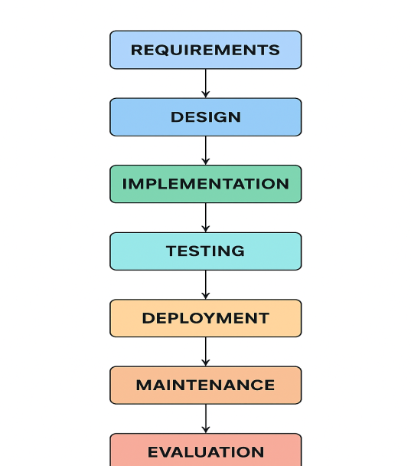
THEORY EXERCISE: What are the main stages of the software development process?
- The Software Development Life Cycle (SDLC) is a structured process used to develop high-quality software.
It includes the following major stages:

1. Requirement Analysis
- Gather and understand what the client or user needs.
- Define the system goals and constraints.

2. Planning
- Estimate resources, cost, and time.
- Create a development plan and assign responsibilities.

3. Design
- Create system architecture, database design, user interface design, and technical specifications.
- This stage decides how the system will work.

4. Development (Coding)
- Programmers write the actual source code.
- Follows the design specifications.

5. Testing
- Test the software for bugs, errors, and issues.
- Ensure the system meets the requirements and works correctly.

6. Deployment
- Release the software to the user or client.
- May be done in phases.

7. Maintenance
- Fix issues reported by users.
- Update or improve the system over time.

📘 Short Exam Answer
The main stages of the SDLC are:
Requirement Analysis, Planning, Design, Development, Testing, Deployment, and Maintenance.

- Software Requirement
LAB EXERCISE: Write a requirement specification for a simple library management system.
1. Introduction
The Library Management System (LMS) is software designed to manage book records, member information, issuing and returning transactions, and inventory tracking for a library.

2. System Objectives
- Automate the process of issuing and returning books
- Maintain accurate records of books and members
- Reduce manual errors
- Generate useful reports (issued books, overdue books, etc.)
- Provide easy search and tracking of books

3. Functional Requirements
3.1 User Management
- Admin can add, update, or delete librarian accounts.
- Librarians can log in using a username and password.
3.2 Book Management
- Add new books to the system
- Update book details
- Delete books from the inventory
- Search for books by title, author, ISBN, or category
- View book availability (available/issued)
3.3 Member Management
- Add new members
- Update member details
- Remove members
- Search members
3.4 Issuing & Returning Books
- Issue a book to a member
- Return a book
- Display due date
- Calculate and display fines for overdue books
3.5 Reports
- Daily issued/returned books report
- Overdue books report
- Inventory list of all books

4. Non-Functional Requirements
4.1 Performance
- System should support at least 50 concurrent users
- Search results should return within 2 seconds
4.2 Security
- Passwords must be stored securely
- Only admins can manage librarian accounts
4.3 Usability
- User interface should be simple and easy to navigate
- Provide helpful error messages
4.4 Reliability
- System should ensure data accuracy and prevent duplication
- Automatic backup of data every 24 hours

5. System Constraints
- Database: MySQL or MongoDB
- Platform: Web-based application
- Technologies: HTML, CSS, JavaScript, Node.js (example stack)

💡 Short Exam-Ready Version
A Library Management System requires modules for user management, book management, member management, issuing/returning books, and reporting.
It must be secure, fast, reliable, and user-friendly.

THEORY EXERCISE: Why is the requirement analysis phase critical in software development?
- Requirement analysis is one of the most important phases in software development because:
1. Defines Clear Goals
It helps developers understand what the client wants so the final product meets expectations.
2. Prevents Costly Mistakes
Early identification of requirements reduces rework, saving time and money.
3. Improves Communication
Ensures developers, designers, testers, and clients share the same understanding.
4. Helps in Planning
Accurate requirements help estimate time, cost, resources, and project feasibility.
5. Ensures User Satisfaction
A well-defined requirement leads to software that actually solves the user’s problem.
6. Foundation for Design & Testing
All later stages—design, coding, testing—depend on correct requirements.

📘 Short Exam Answer
Requirement analysis is critical because it defines what the system must do, prevents misunderstandings, reduces errors, guides all later development stages, and ensures the final software meets user needs.

- Software Analysis
LAB EXERCISE: Perform a functional analysis for an online shopping system.
- A functional analysis identifies what the system must do.
Below is a clear and structured list of major functional requirements for an Online Shopping System.

1. User Management
- Users can create an account (registration).
- Users can log in/out securely.
- Users can update their profile details.
- Users can reset their password.

2. Product Browsing
- Users can browse products by categories.
- Users can search products by name, brand, or keyword.
- Users can view product details (price, images, description, ratings, stock).

3. Shopping Cart Management
- Users can add items to the cart.
- Users can remove items from the cart.
- Users can update item quantity.
- Cart should display the total price.

4. Order Management
- Users can place an order from the cart.
- System calculates total cost including taxes and shipping.
- System generates order confirmation.
- Users can view order history.

5. Payment Processing
- Supports multiple payment methods (credit card, UPI, net banking).
- Secure payment gateway integration.
- Transaction success or failure messages displayed to users.

6. Inventory Management
- System updates stock levels after each purchase.
- Admin can add, update, or delete products.
- Admin can manage product categories.

7. Delivery & Tracking
- Users can enter delivery address.
- System assigns delivery status (processing, shipped, delivered).
- Users can track their order.

8. Review & Rating System
- Users can submit product reviews.
- Users can rate products.
- System displays reviews and ratings on product pages.

9. Notifications
- Users receive email/SMS/app notifications for order confirmation, shipment, and delivery.

10. Admin Dashboard
- Admin can view all orders.
- Admin can manage users, products, and inventory.
- Admin can generate sales reports.

📌 Short Exam Answer (Functional Analysis Summary)
The online shopping system must manage users, allow product browsing, handle carts, process payments, track orders, support reviews, send notifications, and provide admin tools for product and order management.

THEORY EXERCISE: What is the role of software analysis in the development process?
- Software analysis is a crucial early phase in software development. It ensures the system is clearly understood before design and coding begin.

Importance of Software Analysis
1. Identifies User Needs
It helps developers understand what the users and clients expect from the system.
2. Defines System Requirements
Analysis converts user needs into clear functional and non-functional requirements.
3. Reduces Errors & Rework
Finding problems early prevents costly mistakes during coding or testing phases.
4. Supports Better Design
A correct analysis gives a strong foundation for system design and architecture.
5. Ensures Project Feasibility
Helps assess timelines, cost, budget, and required resources.
6. Improves Communication
Ensures all stakeholders (developers, clients, testers) have a shared understanding of the system.
7. Guarantees Quality
The better the analysis, the higher the chances the final software will work correctly and satisfy users.

📘 Short Exam Answer
Software analysis identifies user needs, defines clear requirements, prevents misunderstandings, reduces development errors, and provides the foundation for good design and accurate project planning.

- System Design
LAB EXERCISE: Design a basic system architecture for a food delivery app.
- Here is a simple and clear architecture that you can use in your assignment.

⭐ 1. Client Layer (Front-End)
Used by customers, delivery partners, and restaurant owners.
Components
- Mobile App (Android/iOS)
- Web App
- User Interface (menus, cart, order status)
Functions
- Browse restaurants and food items
- Add food to cart
- Place orders
- Track delivery
- Make payments

⭐ 2. Application Layer (Back-End Services)
The main logic of the app runs here.
Services
- User Service – Login, registration, profiles
- Restaurant Service – Menu, food details, availability
- Order Service – Create and manage orders
- Delivery Service – Assign drivers, track delivery
- Payment Service – Handles online payments (UPI, card, wallet)
- Notification Service – Sends SMS/push notifications
Technologies
Node.js, Java, Python, APIs, Microservices

⭐ 3. Database Layer
Databases Used
- User Database – user details, addresses
- Restaurant Database – menus, pricing
- Order Database – order history, status
- Delivery Database – driver data, routes
- Payment Database – transaction records
Types
- SQL (MySQL/PostgreSQL) for structured data
- NoSQL (MongoDB) for flexible menu data

⭐ 4. External Integrations
- Payment Gateways – Razorpay, PayPal, Stripe
- Maps API – Google Maps for tracking
- SMS/Email API – for notifications

⭐ 5. Admin Dashboard
Used by app owners for monitoring:
- Users
- Orders
- Payments
- Restaurant performance
- Delivery partners

📌 Short Summary of Architecture
A food delivery app contains a front-end, back-end services, databases, external integrations, and an admin dashboard, all working together to manage ordering, delivery, payments, and tracking.

THEORY EXERCISE: What are the key elements of system design?
- System design is the process of defining the architecture, components, modules, and data flow of a system.
It ensures the system is efficient, scalable, and easy to maintain.

⭐ 1. Architecture Design
Defines how the system is structured:
- Client-server
- Three-tier architecture
- Microservices
- Cloud-based architecture

⭐ 2. Data Design
Defines how data will be:
- Stored
- Organized
- Accessed
- Secured
Includes ER diagrams, database schema, and data models.

⭐ 3. Interface Design
Describes how:
- Users interact with the system (UI/UX)
- Components interact using APIs

⭐ 4. Component/Module Design
Breaks the system into smaller parts:
- User module
- Order module
- Payment module
Each module performs a specific function.

⭐ 5. Security Design
Includes:
- Authentication and authorization
- Data encryption
- Secure communication (HTTPS)

⭐ 6. Performance & Scalability Design
Ensures the system can:
- Handle high traffic
- Load balance
- Scale horizontally or vertically

⭐ 7. Error Handling & Logging
Ensures the system can detect, record, and handle errors effectively.

⭐ 8. Deployment Design
Where and how the system will run:
- Cloud servers (AWS, Azure, GCP)
- Containers (Docker)
- Continuous deployment (CI/CD)

📘 Short Exam Answer
Key elements of system design include architecture design, data design, interface design, module design, security planning, performance considerations, error handling, and deployment planning.

- Software Testing .
LAB EXERCISE: Develop test cases for a simple calculator program.
Assume the calculator supports:
➤ Addition
➤ Subtraction
➤ Multiplication
➤ Division
Here are well-structured test cases:

1. Addition Test Cases
Test Case ID | Input | Expected Output | Description
ADD-01 | 5 + 3 | 8 | Normal addition
ADD-02 | -2 + 4 | 2 | Negative + positive
ADD-03 | 0 + 9 | 9 | Adding zero
ADD-04 | 9999 + 1 | 10000 | Large numbers

2. Subtraction Test Cases
Test Case ID | Input | Expected Output | Description
SUB-01 | 9 - 4 | 5 | Normal subtraction
SUB-02 | 3 - 7 | -4 | Negative result
SUB-03 | 0 - 5 | -5 | Zero minus number

3. Multiplication Test Cases
Test Case ID | Input | Expected Output | Description
MUL-01 | 4 × 5 | 20 | Normal multiplication
MUL-02 | -3 × 6 | -18 | Negative × positive
MUL-03 | 0 × 20 | 0 | Multiply by zero

4. Division Test Cases
Test Case ID | Input | Expected Output | Description
DIV-01 | 10 ÷ 2 | 5 | Normal division
DIV-02 | 9 ÷ 0 | Error | Division by zero
DIV-03 | -12 ÷ 3 | -4 | Negative ÷ positive

5. Invalid Input Test Cases
Test Case ID | Input | Expected Output | Description
INV-01 | “A + 2” | Error | Alphabetic input
INV-02 | “5 ? 3” | Error | Unsupported operator
INV-03 | Blank input | Error | Missing values

These test cases cover:
✔ Valid inputs
✔ Edge cases
✔ Error handling
✔ Negative values

THEORY EXERCISE: Why is software testing important?
- Software testing is a crucial part of the software development process because it ensures the final product is reliable, secure, and performs as expected.

⭐ 1. Ensures Software Quality
Testing helps detect bugs so the software works correctly and smoothly.

⭐ 2. Prevents Failures
Early detection of defects prevents major issues after deployment.

⭐ 3. Improves Security
Testing identifies vulnerabilities that could be exploited by attackers.

⭐ 4. Saves Time and Cost
Fixing errors early is cheaper than fixing them after release.

⭐ 5. Ensures User Satisfaction
Well-tested software provides a better experience, leading to happier users.

⭐ 6. Validates Requirements
Testing checks whether the software meets the user’s needs and project goals.

⭐ 7. Improves Performance
Performance testing ensures the software runs efficiently under different loads.

📘 Short Exam Answer
Software testing is important because it detects bugs, improves quality, ensures security, reduces development cost, and ensures the software meets user requirements.

- Maintenance
LAB EXERCISE: Document a real-world case where a software application required critical maintenance.
- Case Study: WhatsApp Global Outage (October 2022)
Description of Issue:
In October 2022, WhatsApp experienced a worldwide outage where users were unable to send or receive messages for nearly two hours.
Cause of the Problem:
The issue was traced to a server configuration change in WhatsApp’s backend infrastructure, which caused communication failures between services.
Type of Maintenance Required:
This incident required Corrective Maintenance — fixing errors that emerged in the operational environment.
Steps Taken:
- Engineers identified the configuration error in the server backend.
- The faulty configuration was rolled back.
- Systems were restarted to restore global communication.
- Additional logs and monitoring were added to prevent recurrence.
Outcome:
Service was fully restored, and WhatsApp improved internal testing and deployment processes to avoid similar outages.

📌 Summary (Short Answer):
WhatsApp’s 2022 outage required critical maintenance due to a backend configuration error. Engineers performed corrective maintenance and restored services globally.

THEORY EXERCISE: What types of software maintenance are there?
- Software maintenance is the process of modifying and updating software after deployment to fix issues, improve performance, or adapt to changes.
There are four main types:

1. Corrective Maintenance
Fixes errors and bugs found after the software is released.
Examples:
- Fixing crashes
- Correcting wrong output
- Repairing security vulnerabilities

2. Adaptive Maintenance
Updates software to adapt to changes in the environment.
Examples:
- Updating software due to OS upgrades
- Supporting new hardware
- Updating APIs

3. Perfective Maintenance
Improves software performance and adds new features based on user feedback.
Examples:
- Adding new buttons or options
- Enhancing UI
- Speeding up a slow function

4. Preventive Maintenance
Improves the software to prevent future issues.
Examples:
- Refactoring code
- Improving documentation
- Database optimization

📘 Short Exam Answer
The four types of software maintenance are corrective, adaptive, perfective, and preventive maintenance. Corrective fixes errors, adaptive adjusts to environmental changes, perfective enhances performance and adds features, and preventive reduces future risks.

- Development .THEORY EXERCISE: What are the key differences between web and desktop applications?
- Web and desktop applications both allow users to perform tasks, but they work in different ways and have different characteristics.

🔹 1. Platform Dependency
Web Applications
- Run in a web browser (Chrome, Firefox, Edge).
- Work on any device with internet access.
- No installation required.
Desktop Applications
- Installed directly on a computer.
- Platform-dependent (Windows, macOS, Linux).

🔹 2. Installation
Web Apps
- Do NOT need installation.
- Updated automatically by the server.
Desktop Apps
- Must be downloaded and installed.
- Need manual updates or auto-updater tools.

🔹 3. Internet Requirement
Web Apps
- Usually require internet to run.
- Some work offline (e.g., Google Docs offline mode).
Desktop Apps
- Can work fully offline once installed.

🔹 4. Performance
Web Apps
- Dependent on browser performance and internet speed.
- May be slower for heavy tasks.
Desktop Apps
- Generally faster and more powerful.
- Better for resource-heavy tasks (video editing, gaming).

🔹 5. Storage
Web Apps
- Data is stored on remote servers (cloud storage).
Desktop Apps
- Data is stored locally on the device (hard drive).

🔹 6. Accessibility
Web Apps
- Accessible from anywhere, any device.
- Only need a browser.
Desktop Apps
- Accessible only on the device where installed.

🔹 7. Development Complexity
Web Apps
- Built using HTML, CSS, JavaScript, frameworks.
- Need backend + frontend integration.
Desktop Apps
- Developed using OS-specific languages (C#, Java, C++, Swift).

🔹 8. Security
Web Apps
- More exposed to online threats (hacking attempts).
- Require HTTPS, authentication, server security.
Desktop Apps
- More control over data security.
- Local threats like malware or unauthorized access.

📘 Short Exam Answer
Web applications run in browsers, require internet, need no installation, and are accessible from anywhere. Desktop applications must be installed, run directly on the operating system, work offline, and offer better performance for heavy tasks. They differ in platform dependency, updates, storage, performance, and security requirements.

- Web Application
THEORY EXERCISE: What are the advantages of using web applications over desktop applications?
- Web applications offer multiple benefits that make them popular for modern software development. Here are the key advantages:

🔹 1. No Installation Required
- Users can access the web app directly through a browser.
- Saves storage space on devices.
- Eliminates installation and setup time.

🔹 2. Accessible From Anywhere
- Users only need an internet connection and a browser.
- Works on laptops, tablets, and mobiles.
- Ideal for remote work, online learning, and cloud applications.

🔹 3. Automatic Updates
- Developers update the web app on the server.
- All users instantly get the latest version.
- No need to manually download updates.

🔹 4. Platform Independent
- Works on Windows, macOS, Linux, Android, and iOS.
- No need to build separate versions for each OS.

🔹 5. Easy Maintenance
- All code runs on the server, making troubleshooting easier.
- Bugs can be fixed without affecting the user’s computer.

🔹 6. Lower Hardware Requirements
- The browser handles most tasks.
- Users don’t need high-performance machines.
- Ideal for older or low-end devices.

🔹 7. Centralized Data Storage
- Data is stored on cloud servers.
- Easy to back up, secure, and manage.
- Users can access their data from any device.

🔹 8. Better Collaboration
- Multiple users can work together in real time (e.g., Google Docs).
- Ideal for team projects and business tasks.

📘 Short Exam Answer
Web applications require no installation, run on any device, provide automatic updates, store data online, are easy to maintain, and support collaboration. They are more accessible, platform-independent, and convenient compared to desktop applications.

- Designing
THEORY EXERCISE: What role does UI/UX design play in application development?
- UI/UX design is a crucial part of building any software application because it impacts how users interact with the system and how they feel while using it.

🔹 1. Enhances User Experience
UX (User Experience) design ensures that the application is:
- Easy to use
- Intuitive
- Efficient
- Enjoyable
A good UX reduces user frustration and improves overall satisfaction.

🔹 2. Improves Usability
UI/UX design focuses on how easily users can complete tasks.
Good usability means:
- Clear navigation
- Simple workflow
- Minimal confusion
This makes the application more effective and user-friendly.

🔹 3. Increases User Engagement
A well-designed interface encourages users to stay longer and interact more with the application.
Examples:
- Clean layout
- Attractive visuals
- Responsive animations

🔹 4. Builds Brand Identity
UI (User Interface) design includes colors, fonts, icons, and styles that represent the brand.
A consistent design strengthens brand recognition and trust.

🔹 5. Reduces Development Costs
Proper UI/UX planning prevents:
- Rework
- Frequent changes
- User complaints
Good design early in development saves time and money later.

🔹 6. Boosts Accessibility
UI/UX ensures the app is accessible to:
- People with disabilities
- Users of different ages
- Users with different technical skills
Accessible design increases the app’s reach.

🔹 7. Supports Business Goals
Good UI/UX helps the app achieve its purpose — such as increasing sales, improving productivity, or delivering services efficiently.

📘 Short Exam Answer
UI/UX design makes applications easier, more enjoyable, and more efficient to use. It improves usability, boosts user satisfaction, strengthens brand identity, reduces development costs, and helps the application achieve its business goals.

- Mobile Application
THEORY EXERCISE: What are the differences between native and hybrid mobile apps?
Mobile apps can be developed using different approaches depending on performance needs, budget, and platform support. The two most common types are native apps and hybrid apps.

🔹 1. Definition
Native Apps
- Built specifically for one platform (Android or iOS).
- Use platform-specific languages like:
  - Java/Kotlin (Android)
  - Swift/Objective-C (iOS)
Hybrid Apps
- Built using web technologies (HTML, CSS, JavaScript).
- Wrapped in a native container (e.g., using React Native, Ionic, Flutter).
- Work on both Android and iOS.

🔹 2. Performance
Native Apps
- Fastest performance.
- Smooth animations and better responsiveness.
- Ideal for games, heavy graphics, and large apps.
Hybrid Apps
- Slightly slower than native.
- Performance depends on the framework and device.

🔹 3. User Experience (UI/UX)
Native Apps
- Best UI/UX because they follow platform guidelines.
- Look and feel matches OS standards.
Hybrid Apps
- UI/UX may not be as consistent across devices.
- Depends on framework capabilities.

🔹 4. Development Time & Cost
Native Apps
- More expensive.
- Require separate development for Android and iOS.
Hybrid Apps
- Faster and cheaper development.
- One codebase works on multiple platforms.

🔹 5. Access to Device Features
Native Apps
- Full access to all device features:
  - Camera
  - GPS
  - Bluetooth
  - Sensors
  - Storage
Hybrid Apps
- Limited or plugin-based access to device hardware.
- May require third-party libraries.

🔹 6. Maintenance
Native Apps
- Harder to maintain (two separate codebases).
Hybrid Apps
- Easier to maintain (one codebase for all platforms).

🔹 7. Offline Support
Native Apps
- Excellent offline capabilities.
Hybrid Apps
- Offline support depends on the framework.

📘 Short Exam Answer
Native apps are platform-specific, faster, and offer better performance and UI/UX but are costly to develop and maintain. Hybrid apps use a single codebase for multiple platforms, are cheaper and faster to build, but offer lower performance and limited access to device features.

- DFD (Data Flow Diagram)
LAB EXERCISE: Create a DFD for a hospital management system.
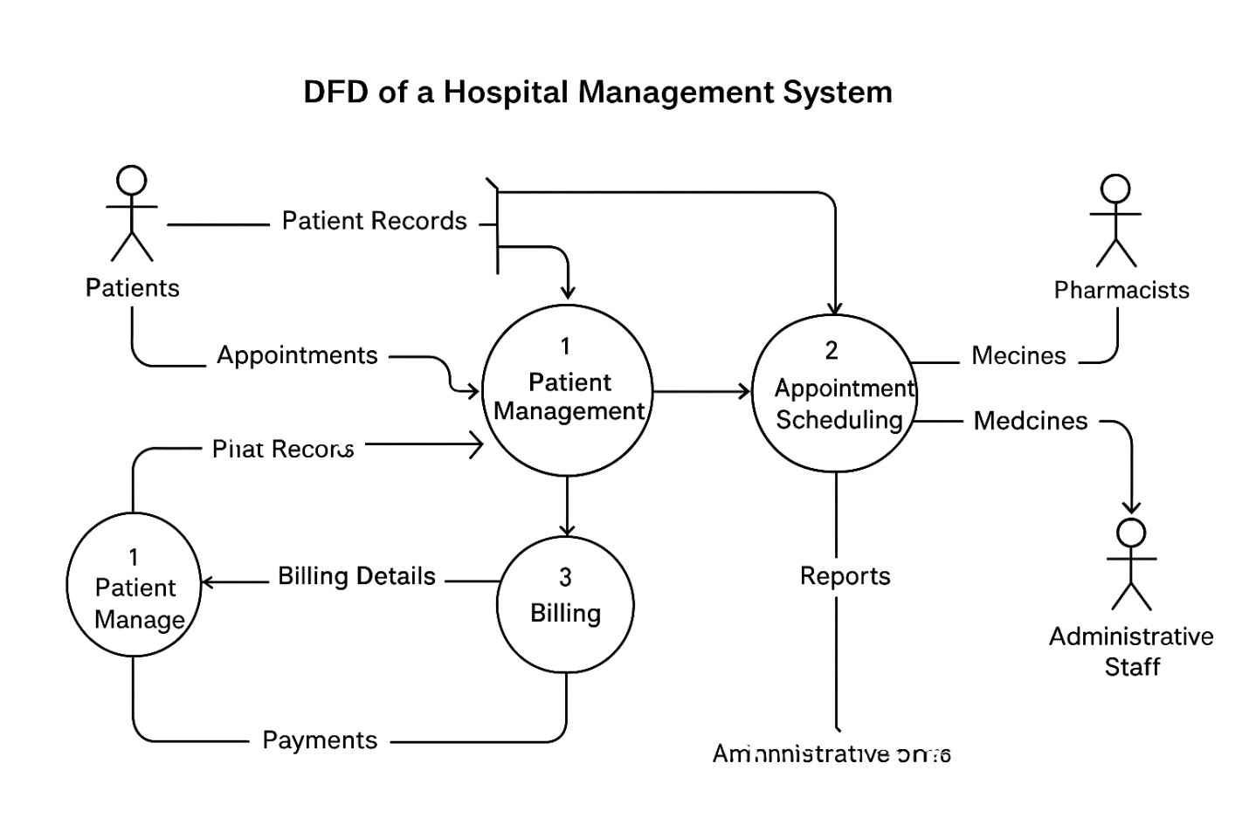

THEORY EXERCISE: What is the significance of DFDs in system analysis?
- A Data Flow Diagram (DFD) is a visual tool used to represent how data moves through a system. It helps analysts, developers, and stakeholders understand the workflow of information inside a system.

🔹 1. Helps Understand System Processes
DFDs show the flow of data between processes, data stores, and external entities.
This makes it easier to understand what the system does and how it behaves.

🔹 2. Provides a Clear Visual Representation
DFDs simplify complex systems by presenting them visually rather than in long text descriptions.
This helps stakeholders understand the system quickly.

🔹 3. Identifies Inputs and Outputs
They clearly show:
- Where data comes from
- How it is processed
- Where it goes
This ensures that nothing important is missed during analysis.

🔹 4. Supports Requirements Analysis
DFDs help analysts verify that user requirements are correctly captured and understood.
It prevents misunderstanding between users and developers.

🔹 5. Helps Detect Inefficiencies or Problems
By analyzing the data flow:
- Redundant steps
- Missing processes
- Bottlenecks
can be easily identified.

🔹 6. Serves as a Blueprint for System Design
DFDs act as a foundation for:
- Database design
- System architecture
- Process design
This ensures the system is built correctly from the start.

🔹 7. Enhances Communication
DFDs provide a common language between:
- Developers
- Analysts
- Clients
- Stakeholders
Everyone can understand how the system works.

📘 Short Exam Answer
DFDs are important in system analysis because they visually represent how data flows through a system, helping identify processes, inputs, outputs, and data stores. They improve understanding, support requirement analysis, detect inefficiencies, and act as a blueprint for designing the system.

- Desktop Application
THEORY EXERCISE: What are the pros and cons of desktop applications compared to web applications?
- Advantages of Desktop Applications
1. Higher Performance
- Faster and more responsive than web apps.
- Better for heavy tasks like video editing, gaming, and large data processing.
2. Can Work Fully Offline
- No internet connection needed.
- Ideal for isolated environments or remote areas.
3. Full Access to System Hardware
- Can directly use CPU, GPU, USB, File System, Printers, etc.
- More powerful integrations.
4. Better Security (Local Data)
- Sensitive data can be stored locally instead of the cloud.

🔹 Disadvantages of Desktop Applications
1. Requires Installation
- Users must download and install the app.
- Takes storage space.
2. Platform Dependent
- Windows, macOS, and Linux require different versions.
- Increases development cost.
3. Harder to Maintain
- Updates must be downloaded by the user.
- Developers must fix platform-specific issues.
4. Limited Accessibility
- Users can only access the app on the device where it is installed.

🔹 Advantages of Web Applications
1. No Installation Needed
- Runs in a web browser.
- Saves storage and setup time.
2. Works on Any Device
- Platform-independent (laptop, mobile, tablet).
3. Easy Updates
- Updates are done on the server, instantly available to all users.
4. Accessible Anywhere
- Only requires an internet connection.

🔹 Disadvantages of Web Applications
1. Requires Internet
- Cannot work without network access (except limited offline features).
2. Lower Performance
- Slower than desktop apps, especially for heavy tasks.
3. Limited Hardware Access
- Restricted access to OS features like GPU, file system, and USB.
4. Security Risks
- Exposed to online threats like hacking, phishing, and data theft.

📘 Short Exam Answer
Desktop applications offer better performance, offline access, and full hardware control but require installation and are platform-dependent. Web applications are easier to access, update, and maintain but rely on internet connectivity and offer lower performance.

- Flow Chart

LAB EXERCISE: Draw a flowchart representing the logic of a basic online registration system.
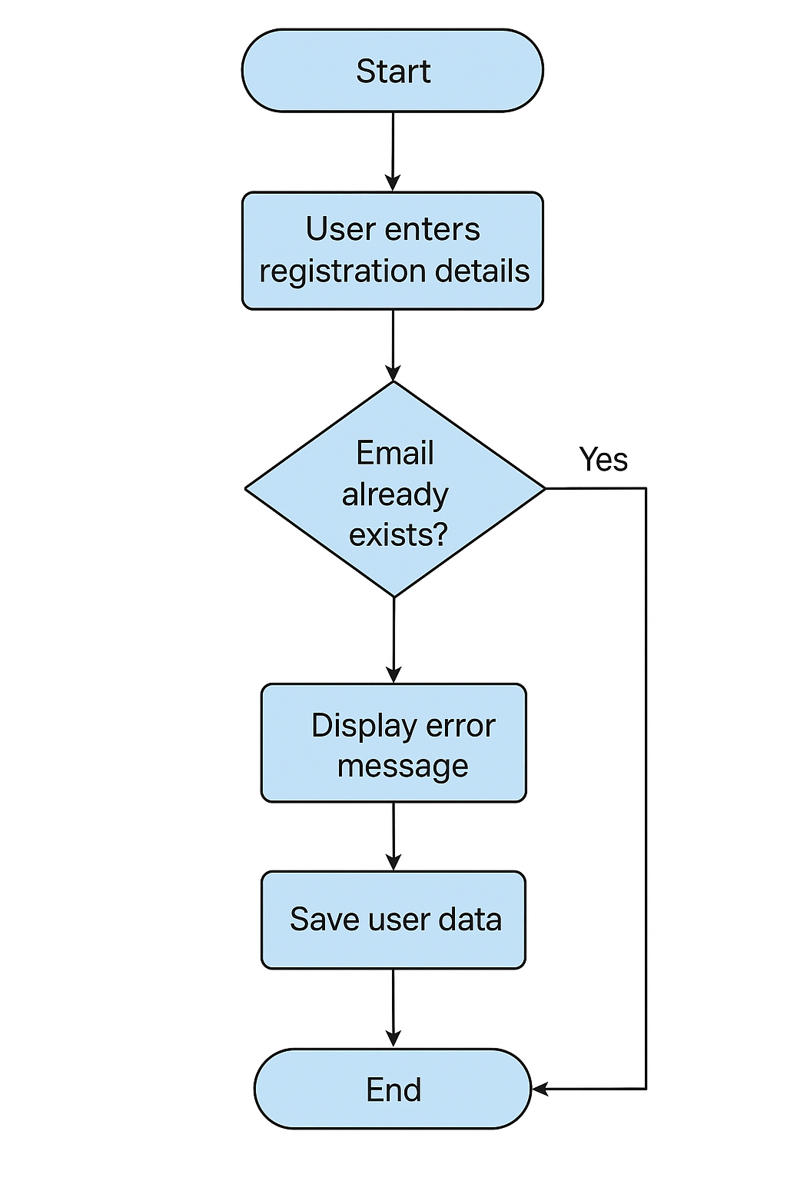
THEORY EXERCISE: How do flowcharts help in programming and system design?
- Flowcharts are important visual tools used to plan, understand, and communicate how a program or system works. Their significance includes:
🔹 1. Provide a Clear Visual Representation
Flowcharts show the flow of steps in a process, making it easier to understand complex logic at a glance.
🔹 2. Improve Problem-Solving
Programmers can identify the correct sequence of operations, conditions, loops, and decisions before writing code.
🔹 3. Reduce Errors in Development
Designing logic first helps catch mistakes early, preventing bugs during coding.
🔹 4. Enhance Communication
Teams (developers, testers, clients) can easily understand the system workflow without needing technical knowledge.
🔹 5. Serve as Documentation
Flowcharts act as reference documents for future system updates, debugging, or maintenance.
🔹 6. Help in System Design
They outline processes, inputs, outputs, and decision points, making system architecture more organized and structured.
📘 Short Exam Answer
Flowcharts help by visually describing the logic and flow of a system, improving understanding, simplifying communication, reducing errors, and supporting better system and program design.

